INT-353

EDA PROJECT

NAME: Lakshya Sharma

Reg. No.: 12107776

Section: K21UT

Roll No.: RK21UTA25

MY DATASET

FT Global Business School MBA Ranking 2023

Introduction:

Domain/Topic knowledge:

* I have chosen a dataset from Kaggle. It is about FT global ranking of MBA schools 2023. This dataset contains various information about the top 100 MBA schools in the world.
* In today's rapidly changing landscape of higher education, the pursuit of a Master of Business Administration (MBA) is an extraordinary journey that transforms the lives of students and institutions alike. The FT Global MBA Ranking 2023 dataset provides a captivating window into the realm of business education, offering a treasure trove of diverse metrics and indicators. Each of these metrics illuminates a distinct facet of MBA programs worldwide.
* Within this dataset lies a rich tapestry of parameters that is immensely valuable for anyone seeking to explore the dynamic world of MBA education. It offers a glimpse into the strengths and areas of improvement for educational institutions, providing insights into their ability to equip students for the constantly evolving global business arena.
* Throughout the course of this Exploratory Data Analysis (EDA) report, we embark on an empirical journey into this domain. Our mission is to navigate through the data and unravel the intricate relationships between various factors and the overall rankings of MBA programs. Our meticulous examination of this dataset aims to unearth valuable insights that can guide prospective students in their educational choices, inform institutions on areas of enhancement, and contribute to the ongoing conversation surrounding business education.
* As we delve into the depths of data analysis and visualization in the subsequent sections, we aim not only to uncover patterns and trends but also to underscore the transformative power of EDA. This process seamlessly transforms raw data into actionable knowledge, effectively bridging the chasm between mere information and enlightened decision-making.

Data Understanding:

Specifying all the information contained within a dataset is a fundamental step in data analysis and is crucial for understanding the dataset's scope, purpose, and potential insights. By providing a comprehensive overview of the dataset's contents, we create a roadmap for ourselves and others

My dataset consists of:

* Dataset Title and Source: FT Global Business School MBA Ranking 2023. Source: Kaggle
* Shape: (101,28)
* Rows: 28
* Columns: 101

Column names and description:

1. Rank: Latest rank of year 2023
2. school name: Name of the school.
3. female faculty %: percentage of female faculty in the school.
4. international mobility rank: Ranking of international mobility opportunities for its students or faculty members.
5. salary today: current or most recent salary earned.
6. international students%: Percentage of international student in the school.
7. weighted salary: reflects the average salary of MBA graduates.
8. international board%: Percentage of international composition or diversity of a governing or advisory board associated with business schools.
9. value of money rank: It the rank of perceived worth of an MBA program in relation to the tuition fees.
10. audit year: year in which the data or information within the dataset was audited or verified.
11. career progress rank: ranking that assesses the career advancement.
12. FT researched rank: Ranked provided by FT research
13. aims achieved%: Percentage of aim achieved by the school
14. sector diversity rank: ranking that evaluates the diversity of sectors or industries in which MBA graduates find employment after completing their MBA programs.
15. location by primary campus: Location of the campus
16. alumni network rank: Rank that assesses the strength and effectiveness of an educational institution's alumni network
17. international faculty%: Percentage of international faculty
18. ESG and net zero teaching rank: ranking that assesses how well MBA programs incorporate and educate students about Environmental, Social, and Governance (ESG) factors.
19. career service rank: ranking that assesses the quality and effectiveness of the career services or career development support offered by MBA programs.
20. overall satisfaction: score that reflects the general level of satisfaction or contentment of individuals who have experienced or interacted with MBA programs.
21. carbon footprint rank: ranking that assesses the environmental impact and sustainability practices of MBA programs.
22. rank in 2022: Rank that was provided to school in year 2022
23. faculty with doctorates%: Percentage of faculty with doctorates.
24. female students%: Percentage of female students in the school
25. international course experience rank: ranking that assesses the extent to which MBA programs provide international and globally-oriented experiences within their courses or curriculum.
26. women on board%: Percentage of women on board in the school
27. rank in 2021: rank that was provided to school in year 2021
28. three-year average rank: average rank of school in past 3 years.

Reasons:

The decision to choose the FT Global MBA Ranking 2023 dataset for this project was not arbitrary but a result of careful consideration, driven by a multitude of compelling reasons that collectively make it an excellent choice for extensive exploration and analysis. I selected this dataset because it offers valuable insights into the world of MBA education. It encompasses a wide range of metrics that evaluate the performance and impact of MBA programs. This data is highly relevant in the context of modern education, providing information on factors like career progress, sector diversity, alumni networks, sustainability, and more. By analyzing this dataset, I aim to uncover trends and insights that can inform prospective students, guide institutions, and contribute to discussions on the quality and value of MBA programs in today's dynamic educational landscape.

Questions for Analysis:

1. What is the overall ranking trend for MBA programs globally in 2023 compared to the previous years?
2. How do MBA programs rank in terms of international faculty diversity?
3. What is the distribution of post-MBA salaries among the top-ranked schools?
4. Are there any correlations between the career progress rank and alumni network rank?
5. Which MBA programs demonstrate the highest value for money based on the dataset?
6. How does the percentage of female students vary across different MBA programs?
7. Can we identify any trends in MBA programs' sector diversity rankings over the years?
8. What are the top-ranked MBA programs for international mobility in 2023?
9. How do MBA programs perform in terms of carbon footprint rankings and ESG teaching?
10. Is there a correlation between the international course experience rank and the overall satisfaction of students?
11. How does the presence of female faculty members correlate with female student?
12. Are there any patterns in the rankings of MBA programs?
13. What is the relationship between the faculty with doctorates and the research rank of MBA programs?
14. How do MBA programs rank in terms of aims achieved, and are there any common themes among the top performers?
15. Can we identify a trend in the number of international students across the schools?
16. What is the correlation between the alumni network rank and the three-year average rank?
17. which are the dominating schools in the top rankings in 2023?
18. How do MBA programs fare in terms of net-zero teaching and international board diversity?
19. Is there a relationship between the percentage of female faculty and the ranking of MBA programs?
20. What insights can be gained from comparing the rankings in 2021, 2022, and 2023, and are there any consistent trends or outliers?

Libraries used and approaches:

In the project involving the analysis of MBA program rankings and related questions, several Python libraries are used to handle data, perform analysis, and create visualizations. Here's a detailed explanation of the libraries used and the approach to solve the problems:

Libraries Used:

Pandas: Pandas is a fundamental library for data manipulation and analysis. It provides powerful data structures like DataFrames and Series, making it easy to work with structured data. Pandas allows us to load, clean, transform, and analyze the dataset efficiently.

Matplotlib: Matplotlib is a widely-used library for creating static, animated, and interactive visualizations in Python. It offers various types of plots, including line plots, bar charts, scatter plots, histograms, and more. Matplotlib is crucial for presenting the results of our analysis visually.

Seaborn: Seaborn is built on top of Matplotlib and provides a higher-level interface for creating aesthetically pleasing statistical graphics. It offers specialized functions for creating complex visualizations like heatmaps, violin plots, and pair plots. Seaborn simplifies the process of creating informative and visually appealing plots.

NumPy: NumPy is a fundamental library for numerical computing in Python. It provides support for working with arrays and matrices, which are essential for mathematical operations, statistical analysis, and data manipulation. NumPy is often used in conjunction with Pandas to perform numerical calculations.

Jupyter Notebook: Jupyter Notebook is an interactive coding environment that allows us to write, execute, and document our Python code in a notebook-style format. It's particularly useful for exploratory data analysis (EDA), as it allows us to combine code, visualizations, and explanations in a single document. Jupyter Notebook facilitates the creation of data science reports and presentations.

Approach to Solve Problems:

1) Data Loading and Inspection:

* Loading the dataset containing MBA program rankings and related attributes using Pandas.
* Inspecting the dataset's structure, including columns, data types, and initial data samples.

2) Data Cleaning and Preprocessing:

* Handling missing values by imputing or removing them based on the context.
* Converting data types to ensure they are suitable for analysis (e.g., converting string representations of numbers to numeric data types).
* Addressing data inconsistencies and outliers that could affect analysis results.

3) Exploratory Data Analysis (EDA):

* Performing EDA to understand the dataset's characteristics and uncover initial insights.
* Generating summary statistics, including measures of central tendency and dispersion.
* Creating visualizations (e.g., histograms, box plots, scatter plots) to visualize data distributions and relationships between variables.

4) Data Visualization:

* Utilizing Matplotlib and Seaborn to create a wide range of visualizations tailored to the specific questions being addressed.
* Visualizing trends, patterns, and correlations in the data.
* Customizing plots with labels, titles, legends, and other elements for clarity.

5) Answering Questions and Problem-Solving:

* Addressing each question or problem statement one by one, writing code to perform the necessary calculations and visualizations.
* Applying domain knowledge and analytical techniques to gain insights.
* Interpreting the results of analyses and visualizations to draw meaningful conclusions.
* Presenting the findings in a clear and organized manner, often using Jupyter Notebook to create comprehensive reports.
* Providing explanations and context for the observed trends and relationships.

6) Iterative Process:

* Data analysis is often iterative. It may involve revisiting previous steps, refining analysis, or exploring additional questions as new insights are uncovered.

This is the outlined approach to address each question or problem systematically and leverage the capabilities of the selected Python libraries to conduct a comprehensive analysis of the MBA program rankings dataset.

Steps of EDA:

Exploratory Data Analysis (EDA) is a critical phase in data analysis that helps us understand the dataset, identify patterns, and gain insights. In the project involving MBA program rankings, the following steps of EDA are used in detail:

1) Importing libraries:

The very first step of EDA was importing Python libraries that are used in MBA program rankings analysis project:

* Data handling: Pandas, NumPy
* Visualization: Matplotlib, Seaborn

2) Data Loading:

* Loading the dataset into a Pandas DataFrame.
* Ensuring that the data is read correctly by checking the first few rows and the column names.
* Understanding the size of the dataset (number of rows and columns).

3) Data Cleaning:

Checking the data types of each column using (“df.dtypes”)

Displaying summary statistics of the DataFrame using (“df.describe()”)

Identifying and handling missing data:

Check for missing values in each column.

Deciding whether to impute missing values, remove rows with missing values, or handle them differently based on context.

* I used Mode fillna to fill missing values of “Rank of 2022” and “Audit year *”
* I used Median fillna to fill missing vales of “Rank of 2021” and “Three-year average rank”

Checking for duplicate rows and removing them if necessary.

In my dataset there were no duplicate rows to remove them. So, this step doesn’t apply to my dataset

Ensure data consistency and uniformity:

Converting data types to appropriate formats (e.g., converting strings to numeric types).

Standardizing data (e.g., removing unnecessary characters, whitespace).

* + - To convert salary strings to numeric data we use

# Ensuring that 'Salary today (US$)' columns are numeric

df['Salary today (US$)'] = pd.to_numeric(df['Salary today (US$) **'].str.replace(',', '',

regex=True), errors='coerce')

4) Data Exploration:

Generating summary statistics:

* + - Calculating descriptive statistics such as mean, median, mode, count etc. to understand the data's central tendencies and spread.

Visualizing data distributions:

* + - Creating histograms, pie charts to visualize the distribution of numerical variables.
    - Using bar plots or count plots for categorical variables.

Exploring relationships:

* + - Constructing scatter plots, line charts or correlation matrices to identify associations between variables.
    - Computing correlation coefficients to quantify relationships.

Handling categorical data:

* + - Examining the frequency distribution of categorical variables using bar plots.
    - Exploring relationships between categorical variables using Heatmaps.

5) Data Visualization:

Creating a variety of plots and charts to visualize data:

* + - Line plots, scatter plots, and bar plots to show trends and relationships.
    - Box plots and violin plots to depict data distributions and identify outliers.
    - Heatmaps to visualize correlations between variables.

Customize visualizations with titles, labels, legends, and color palettes to enhance

clarity.

6) Summary and Insights:

* + - Summarizing key findings, trends, and insights from the EDA process.
    - Providing context and explanations for observed patterns.
    - Formulating preliminary conclusions for further analysis.

7) Documentation:

* + Documenting the EDA process, including code, visualizations, and insights, in a clear and organized manner.
  + Using Jupyter Notebook to create a comprehensive report that can be easily shared and referenced.

The EDA process in this project is systematic and thorough, involving a combination of statistical analysis and data visualization techniques to uncover meaningful insights from the MBA program rankings dataset.

Visualisation of all the Questions for Analysis.

1. What is the overall ranking trend for MBA programs globally in 2023 compared to the previous years?
2. The overall ranking trend for MBA programs globally in 2023 compared to the previous year’s indicates that there has been a change in the rankings of MBA programs over time. To analyze this trend, we have performed the following steps:

* First, we calculated the differences in ranks between 2023 and 2022, and between 2023 and 2021
* Second, we visualize the changes in ranks by plotting the difference in rank for each program in 2023 compared to its previous years.
* Third, we create a bar plot to visualize the overall ranking trend for each year.
* Fourth, this analysis will provide a clear picture of whether MBA programs, on the differences in rank of the schools, have improved or declined in their rankings from 2021 to 2023.

For example:

Insead Business School Current Rank is 2nd. In 2022 it was 3rd and in 2021 it was 1st.

By this we can see that though the rank has decreased from 2021-2023 the school have been performing very well each year to be in Top 3 every year.

1. How do MBA programs rank in terms of international faculty diversity?
2. International faculty plays a vital role in all the Business schools across the globe. Each school has a huge percentage of international faculty. For example: Columbia Business School which ranks first in 2023 rankings has around 58% of international faculty. Insead Business school which ranks second in 2023 ranking has around 90% of international faculty and so on. IMD (International Institute for Management Development) has the highest number of international faculty i.e., around 98%.

Whereas Indian Institute of Management Calcutta and Indian Institute of Management Indore has 0 international faculty. To depict this diversity of international faculty we create a histogram for international faculty diversity. This distribution shows the international faculty % around the school.

1. What is the distribution of post-MBA salaries among the top-ranked schools?
2. The distribution of post-MBA salaries among the top-ranked schools provides valuable insights into the earning potential of graduates from these institutions.

* The distribution of post-MBA salaries among the top-ranked schools is likely to exhibit significant variation. Some schools may have graduates with exceptionally high salaries, while others may have more moderate earnings.
* Salary not only depends upon the ranking of the school but also depends upon how prestigious the school’s name is.
* For example, even though Colombia business school ranks highest but Harvard and Stanford business school have the highest salary today.
* To depict the variation in salaries of top 5 universities we use a pie chart to show the “%” of highest earning schools

1. Are there any correlations between the career progress rank and alumni network rank?

* The correlation coefficient between career progress rank and alumni network rank is approximately 0.2385.
* It is a Weak Positive Correlation. The positive correlation coefficient (0.2385) indicates a weak positive correlation between career progress rank and alumni network rank. This suggests that there is a slight tendency for schools with higher career progress ranks to also have higher alumni network ranks, and vice versa.
* I used a co-relation heatmap to depict the co-relation between the career progress rank and alumni network rank.
* the correlation heatmap serves as a helpful tool to communicate complex relationships between variables in your dataset in a visually intuitive way.
* A positive correlation coefficient of approximately 0.2385, which is a weak positive correlation. The color of the corresponding cell in the heatmap would reflect this positive correlation visually, but it won't be strongly pronounced because of the weak correlation.

1. Which MBA programs demonstrate the highest value for money based on the dataset?
2. Highest value for money is defined as the most advantageous combination of cost, quality and sustainability to meet student requirements.

The top 10 MBA programs demonstrating the highest value for money, along with their respective "Value for Money Score" rankings:

* Tias Business School, Tilburg University - Value for Money Score: 94,786
* Audencia - Value for Money Score: 79,457
* Stanford Graduate School of Business - Value for Money Score: 253,435
* Harvard Business School - Value for Money Score: 235,177
* Columbia Business School - Value for Money Score: 228,425
* University of Chicago: Booth - Value for Money Score: 216,295
* University of California at Berkeley: Haas - Value for Money Score: 213,321
* Northwestern University, Kellogg School of Management - Value for Money Score: 211,718
* MIT: Sloan - Value for Money Score: 207,100
* Insead - Value for Money Score: 202,568

1. How does the percentage of female students vary across different MBA programs?

* Variation in Female Student Percentage: The dataset includes a column called "Female students (%)," which represents the percentage of female students in each MBA program. This percentage varies across different programs, indicating that there is diversity in the representation of female students.
* Programs with Higher Female Enrollment: Some MBA programs may have a higher percentage of female students, suggesting that they may be more attractive to or supportive of female candidates. Ex: Harvard Business School has around 46% of female students.
* Programs with Lower Female Enrollment: Conversely, some programs may have lower percentage of female students, indicating potential areas for improvement in terms of gender diversity. Ex: University of California at Davis has around 33% of female students.

1. Can we identify any trends in MBA programs' sector diversity rankings over the years?
2. To identify trends in MBA programs' sector diversity rankings over the years, we analyzed the provided sector diversity rank data. Here are the key insights:

Fluctuations in Rankings: The sector diversity rankings for MBA programs vary from school to school. Some programs consistently maintain high sector diversity rankings, while others experience fluctuations.

Diversity Efforts: The variations in sector diversity rankings indicate that MBA programs are making efforts to promote diversity within their student bodies, but the results can be variable.

In conclusion, the analysis of sector diversity rankings over the schools shows that MBA programs are actively working to enhance sector diversity. However, the lack of a consistent long-term trend suggests that the rankings are influenced by various factors and can change from school to school.

1. What are the top-ranked MBA programs for international mobility in 2023?
2. The top-ranked MBA programs for international mobility in 2023, based on the provided data, are as follows:
3. HEC Paris
4. IMD – International Institute for Management Development
5. SDA Bocconi School of Management
6. University of California at Berkeley: Haas
7. INSEAD
8. Shanghai University of Finance and Economics: College of Business
9. Esade Business School
10. University of Cambridge: Judge
11. National University of Singapore Business School
12. IE Business School

These programs have been ranked based on their international mobility rank, with lower ranks indicating a higher degree of international mobility. It's important to note that these rankings reflect the international mobility aspect of these MBA programs and may not necessarily represent their overall rankings.

1. How do MBA programs perform in terms of carbon footprint rankings and ESG teaching?

* Carbon Footprint Rank: MBA programs vary significantly in their carbon footprint rankings, which assess the environmental impact and sustainability efforts of these programs. Programs like "HEC Paris," "IE Business School," and "Shanghai University of Finance and Economics: College of Business" have relatively low carbon footprint ranks, indicating strong sustainability practices. On the other hand, programs like "Indian School of Business" and "Boston College: Carroll" have higher carbon footprint ranks, suggesting a larger environmental impact.
* ESG and Net Zero Teaching Rank: The ESG and net zero teaching rank assesses the focus and effectiveness of MBA programs in teaching and promoting Environmental, Social, and Governance principles, as well as net-zero teaching practices. Programs like "Iese Business School," "SDA Bocconi School of Management," and "University of California at Berkeley: Haas" have strong ESG and net-zero teaching ranks, indicating their commitment to sustainability education. Conversely, programs like "University of Chicago: Booth" and "Fudan University School of Management" have lower ranks in this category.

1. Is there a correlation between the international course experience rank and the overall satisfaction of students?
2. The correlation coefficient for the international course experience rank and overall satisfaction score is approximately 0.31.

The positive correlation coefficient (0.31) suggests a weak to moderate positive correlation between the international course experience rank and overall satisfaction of students.

This means that, on average, as the international course experience rank increases (improves), there tends to be a tendency for overall student satisfaction to also increase, and vice versa.

1. How does the presence of female faculty members correlate with female student?
2. The correlation coefficient for Female faculty % and Female students % is approximately 0.135.

The positive correlation coefficient (0.135) suggests a weak positive correlation between the presence of female faculty members and the percentage of female students.

This means that, on average, as the percentage of female faculty members increases, there is a slight tendency for the percentage of female students to also increase, and vice versa.

1. Are there any patterns in the rankings of MBA programs?
2. Consistency at the Top: Some schools consistently maintain top rankings over the two years. Columbia Business School, Insead, and Iese Business School consistently rank high.

Volatile Rankings: Several schools have experienced significant fluctuations in their rankings from one year to the next. For example, Rice University: Jones jumped from 32 to 47, and Imperial College Business School dropped from 44 to 34.

Top U.S. Schools: Top U.S. schools like Harvard Business School, Stanford Graduate School of Business, and MIT: Sloan continue to be highly ranked.

European Presence: European schools like London Business School, HEC Paris, and University of Cambridge: Judge also maintain strong rankings.

Asian Schools: Ceibs, National University of Singapore Business School, and Indian School of Business represent the strong presence of Asian schools in the rankings.

Mixed Trends: Some schools show mixed trends, with fluctuations in rankings in both directions. For example, University of Chicago: Booth ranked 3rd in 2021 but dropped to 7th in 2022.

Notable Gains and Drops: Edhec Business School made a significant jump from 76 to 73, while Michigan State University: Broad and University of Georgia: Terry experienced drops in their rankings.

1. What is the relationship between the faculty with doctorates and the research rank of MBA programs?
2. Correlation coefficient (r): 0.1346 (approximately)

Interpretation: A positive but weak correlation

Based on the correlation coefficient of approximately 0.1346, there is a positive but weak correlation between the percentage of faculty with doctorates and the research rank of MBA programs. This means that, on average, MBA programs with a higher percentage of faculty with doctorates tend to have slightly higher research ranks, but the relationship is not very strong.

1. How do MBA programs rank in terms of aims achieved, and are there any common themes among the top performers?
2. To assess how MBA programs rank in terms of aims achieved, we can analyze the provided data and identify common themes among the top performers. The "Aims Achieved (%)" represents the percentage of aims or goals achieved by each MBA program.

Here are the top 10 MBA programs based on the percentage of aims achieved:

Stanford Graduate School of Business - 93%

Michigan State University: Broad - 93%

Cornell University: Johnson - 92%

Dartmouth College: Tuck - 92%

University of Michigan: Ross - 92%

Harvard Business School - 91%

Columbia Business School - 91%

Yale School of Management - 91%

Duke University's Fuqua School of Business - 91%

MIT: Sloan - 91%

Common themes among the top performers include:

High Aims Achievement: The top-performing MBA programs tend to have a high percentage of aims achieved, indicating that they are successful in meeting their stated goals or objectives.

Prestigious Schools: Many of the top performers are well-known and prestigious business schools, such as Stanford, Harvard, and Columbia.

1. Can we identify a trend in the number of international students across the schools?

A)

European Schools: European business schools tend to have a high percentage of international students. For example, HEC Paris, IE Business School, and INSEAD have percentages in the high 80s and 90s.

US Schools: MBA programs in the United States also have a wide range of percentages. Top US schools like Stanford, Harvard, and Columbia have moderate percentages, ranging from the high 30s to the high 50s.

Asian Schools: Some Asian schools, like the Indian Institutes of Management (Ahmedabad and Bangalore), have very low percentages of international students (0%). However, there are exceptions, such as Nanyang Business School and National University of Singapore Business School, which have higher percentages.

Geographic Variation: The percentage of international students seems to be influenced by the geographic location of the business school. European and Asian schools tend to have higher percentages, while US schools show more variability.

Diversity: MBA programs with higher percentages of international students often offer a more diverse and global learning environment, which can be attractive to students seeking exposure to different cultures and perspectives.

Recruitment Efforts: Schools with higher percentages of international students may have more robust international recruitment efforts and may actively seek to create a diverse student body.

High Variability: There is significant variability in the percentage of international students across MBA programs. Some programs, like ESCP Business School, Bayes Business School, and Tias Business School, have 100% international students, while others have very few international students or even none.

1. What is the correlation between the alumni network rank and the three-year average rank?

A) The correlation coefficient is approximately -0.51.

The correlation coefficient between the alumni network rank and the three-year average rank is approximately -0.51, indicating a moderate negative correlation. This means that as the alumni network rank tends to improve (decrease), the three-year average rank tends to worsen (increase), and vice versa. In other words, schools with stronger alumni networks tend to have lower three-year average ranks, and schools with weaker alumni networks tend to have higher three-year average ranks.

17) Which are the dominating schools in the top rankings in 2023?

A) The following schools can be considered dominating in the top rankings for 2023:

1. Columbia Business School
2. Insead
3. Iese Business School
4. Harvard Business School
5. Stanford Graduate School of Business
6. SDA Bocconi School of Management
7. University of California at Berkeley: Haas
8. Cornell University: Johnson
9. Northwestern University, Kellogg School of Management
10. Yale School of Management
11. Duke University's Fuqua School of Business
12. MIT: Sloan
13. University of Chicago: Booth

These schools consistently appear at the top of the rankings and can be considered the dominating schools in the MBA program rankings for 2023.

18) How do MBA programs fare in terms of net-zero teaching and international board diversity?

A) Correlation Coefficient (ESG and net-zero teaching rank vs. international board diversity): -0.181

The correlation coefficient indicates the strength and direction of the linear relationship between the two variables. In this case, there is a weak negative correlation between ESG and net-zero teaching rank and international board diversity. This means that as the ESG and net-zero teaching rank tends to increase, international board diversity tends to decrease slightly, but the relationship is not very strong.

19) Is there a relationship between the percentage of female faculty and the ranking of MBA programs?

A) Correlation Coefficient (Rank vs. Female faculty %): -0.206

The correlation coefficient is approximately -0.206, which suggests a weak negative correlation between the percentage of female faculty and the ranking of MBA programs. This means that as the percentage of female faculty increases, the ranking tends to be slightly lower, but the relationship is not very strong

20) What insights can be gained from comparing the rankings in 2021, 2022, and 2023, and are there any consistent trends or outliers?

A) Analyzing the rankings for 2021, 2022, and 2023, we can gain several insights:

Consistency in Top Schools:

* Columbia Business School consistently holds the top rank in all three years.
* Insead maintains a strong position within the top 3 in all three years.
* Iese Business School sees an improvement from 2021 to 2022 and remains in the top 3 in 2023.

Harvard and Stanford:

* Harvard Business School was ranked 3rd in both 2021 and 2022, but it did not have a ranking in 2023.
* Stanford Graduate School of Business ranked 6th in 2022 but also did not have a ranking in 2023.

Shifting Rankings:

Several schools have variable rankings across the three years. For example, Northwestern University, Kellogg School of Management, and Duke University's Fuqua School of Business experienced fluctuations in their rankings.

Improved Rankings:

* Some schools, like Dartmouth College: Tuck and London Business School, improved their rankings from 2021 to 2022 but may have seen a slight decrease in 2023.
* Schools with Consistently Lower Rankings:
* Schools like Queen's University: Smith and Boston College: Carroll consistently rank toward the bottom in all three years.

New Entrants and Exits:

Several schools, such as Birmingham Business School, Frankfurt School of Finance and Management, Trinity College Dublin, and The Lisbon MBA Catolica | Nova, do not have rankings for all three years, indicating that they may not have participated or provided data in some years.

Notable Outliers:

There are some outliers where schools have significant changes in rankings between 2021, 2022, and 2023. For instance, Rice University: Jones significantly improved its ranking from 2021 to 2022 but experienced a drop in 2023. This suggests fluctuations in their performance.

Univariate Analysis:

Univariate analysis explores each variable in the dataset, separately.

In this we use appropriate visualizations (histograms, box plots, etc.) to explore their distributions.

* Let’s, first look at MBA programs rank in terms of international faculty diversity

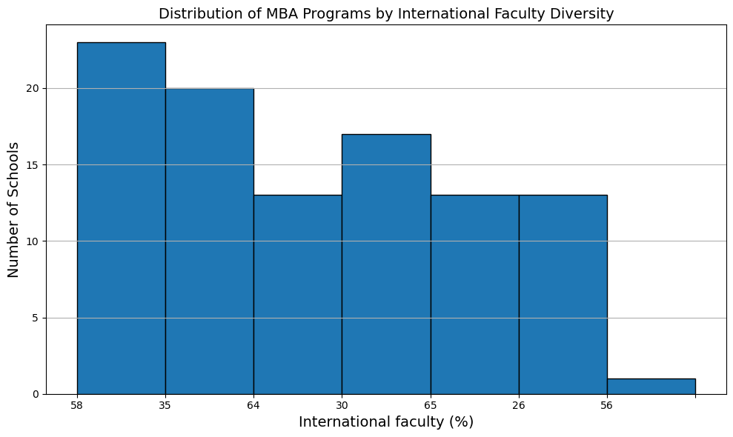

* Now let’s look at, distribution of post-MBA salaries among the top-ranked schools

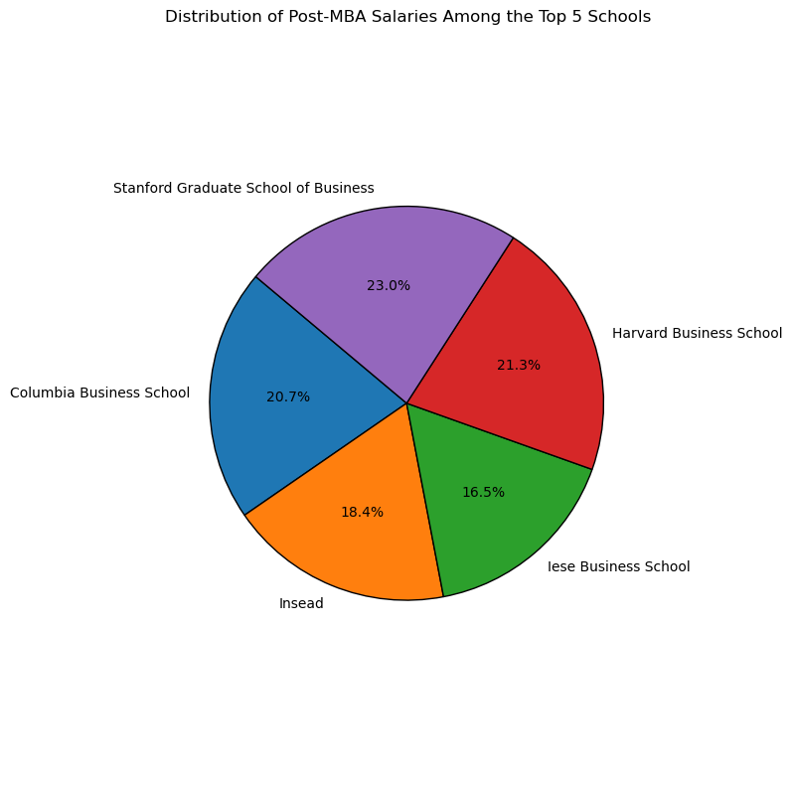

* Now let’s look at, the percentage of female students vary across different MBA programs

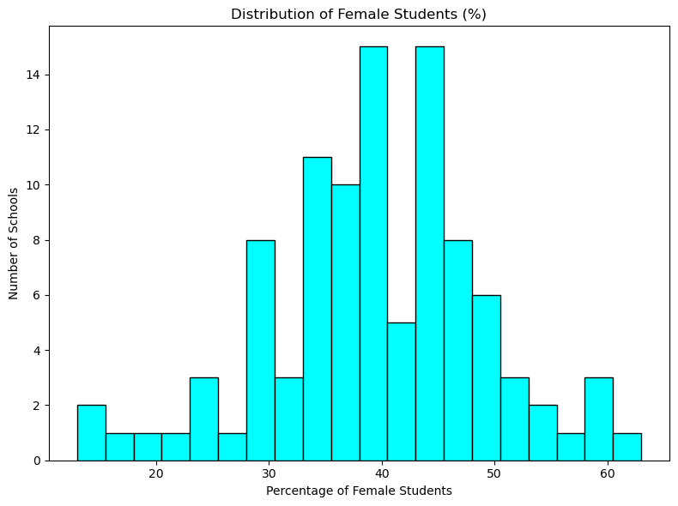

* Now let’s look at, trends in MBA programs' sector diversity rankings

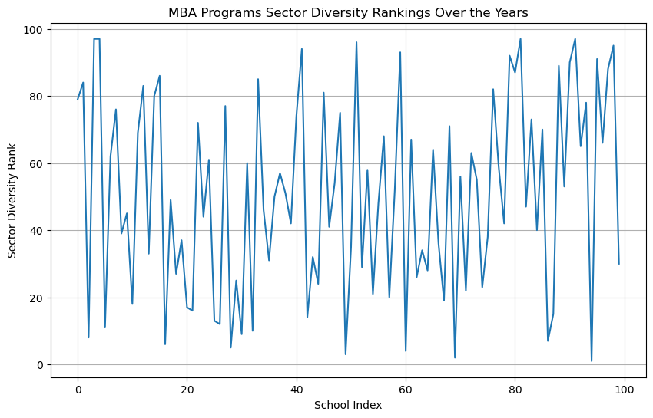

* Now let’s look at, ttop-ranked MBA programs for international mobility in 2023

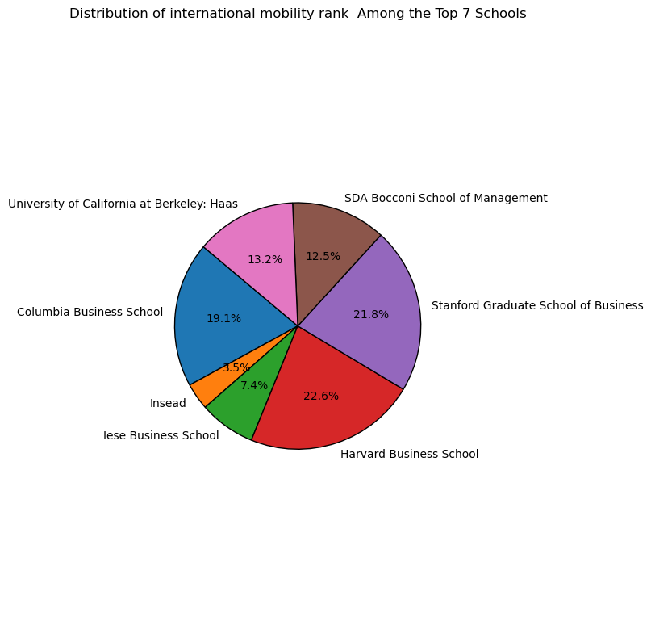

* Now let’s look at, MBA programs perform in terms of carbon footprint rankings and ESG teaching

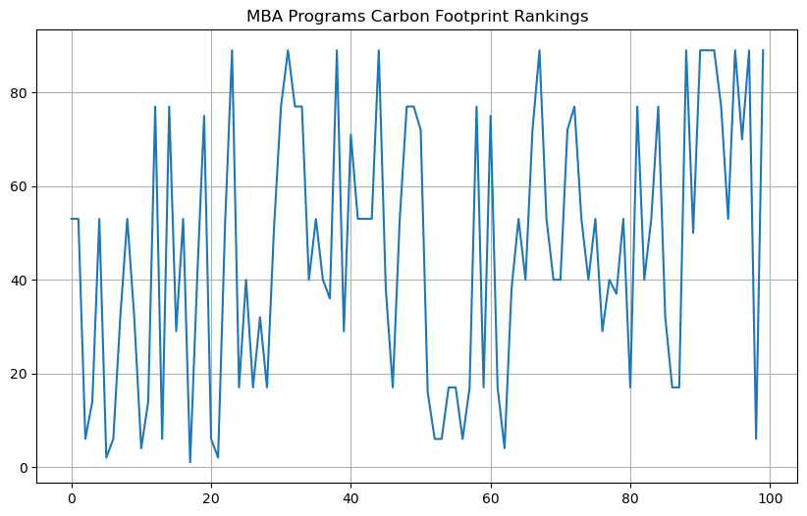

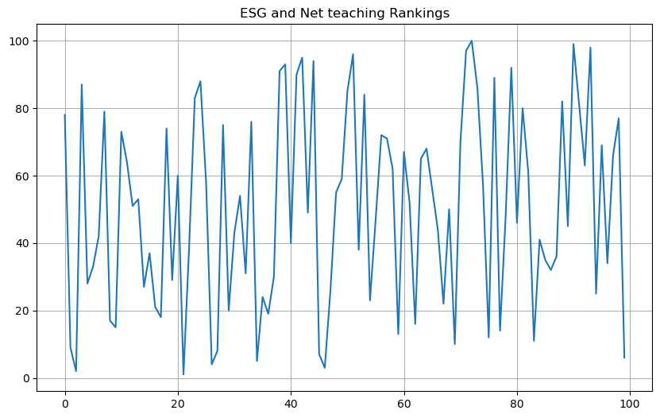

* Now let’s look at MBA programs rank in terms of aims achieved

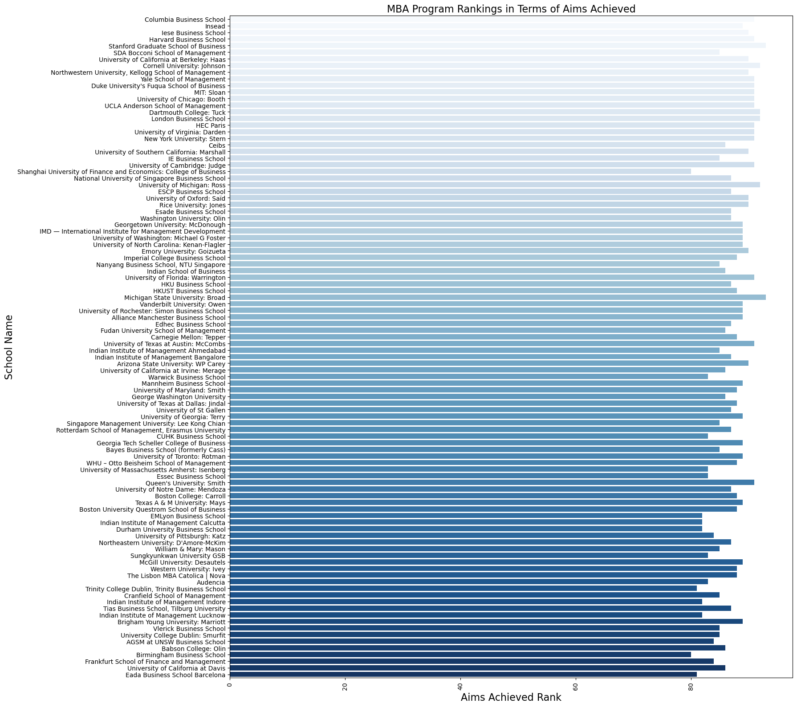

* Now let’s look at, distribution in the number of international students across the schools

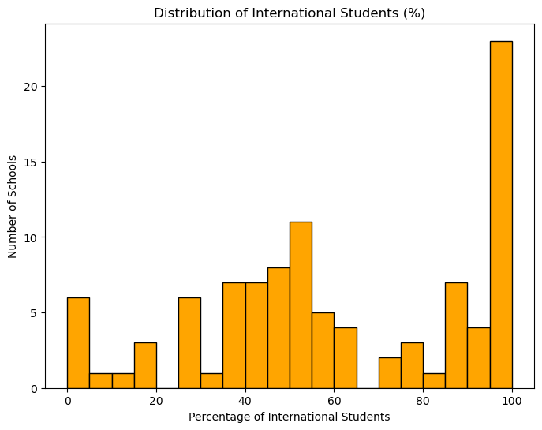

* Now let’s look at, the dominating schools in the top rankings in 2023.

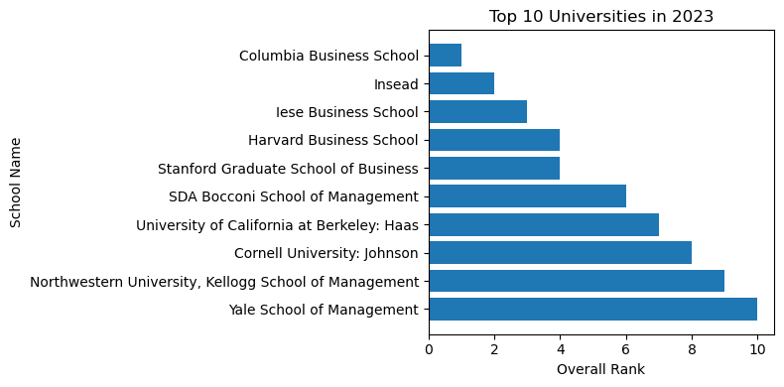

Bivariate Analysis:

Bivariate analysis explores two different variables in the dataset, at the same time.

In this we use scatterplots, correlation matrices, and other visualizations to uncover associations.

* Firstly, let’s see the correlations between the career progress rank and alumni network rank

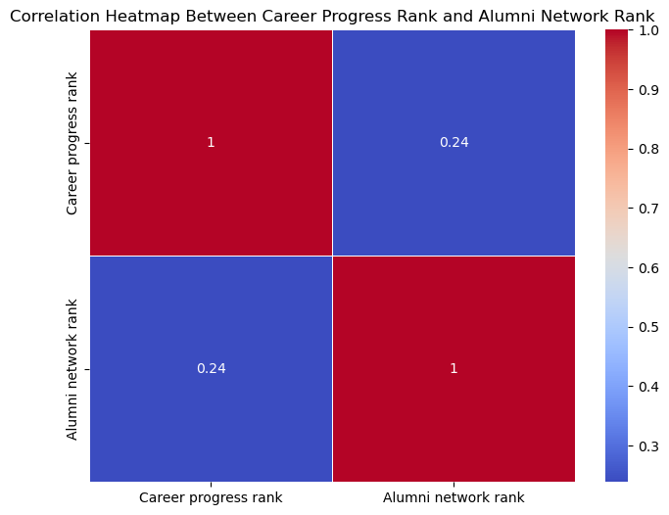

* Now let’s look at, correlation between the international course experience rank and the overall satisfaction of students

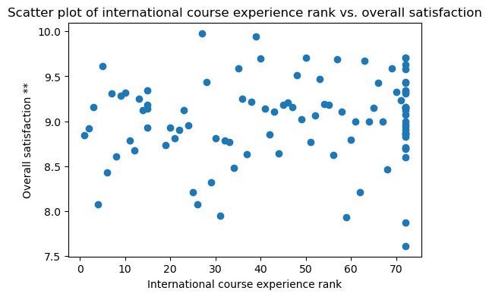

* Now let’s look at, presence of female faculty members correlate with female student enrolment

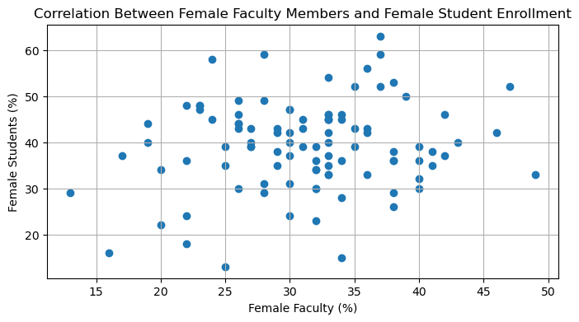

Now let’s look at, relationship between the faculty with doctorates and the research rank of MBA programs

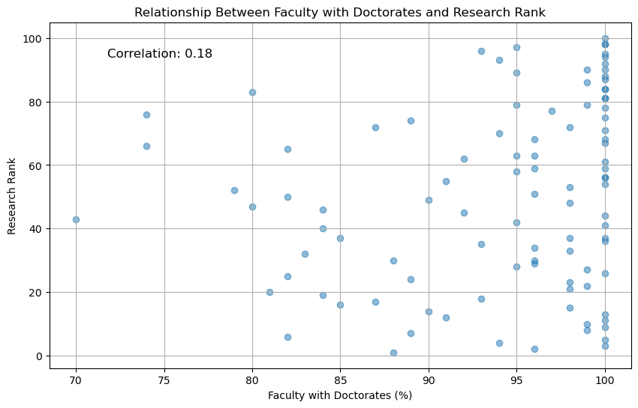

* Now let’s look at, the correlation between the alumni network rank and the three-year average rank

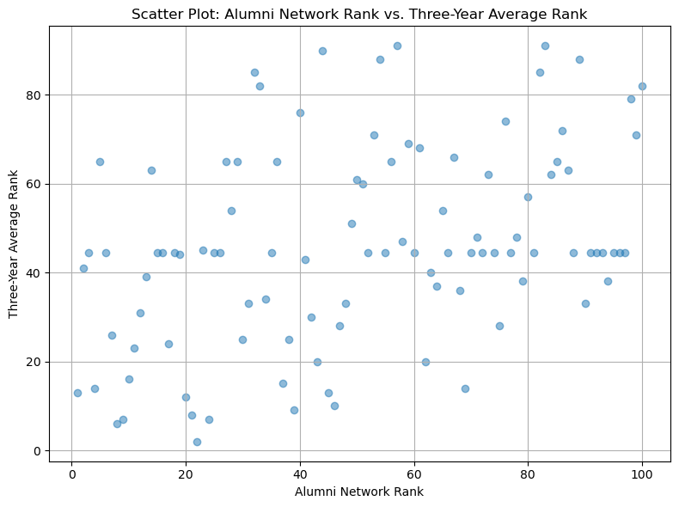

* Now let’s look at, a relationship between the percentage of female faculty and the ranking of MBA programs

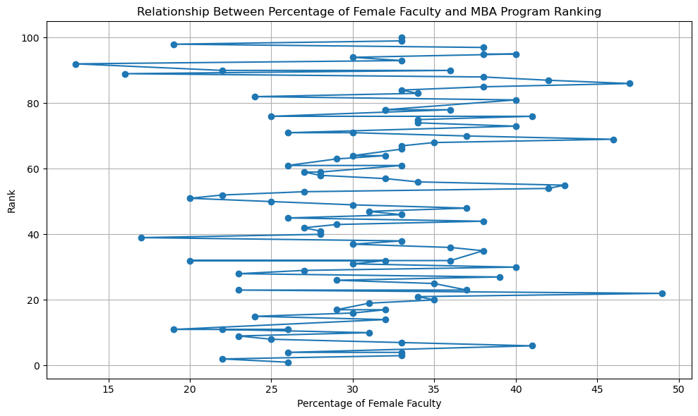

Multivariate Analysis:

In this we explore interactions and correlations among multiple variables.

* First let’s look at the overall ranking trend for MBA programs globally in 2023 compared to the previous years

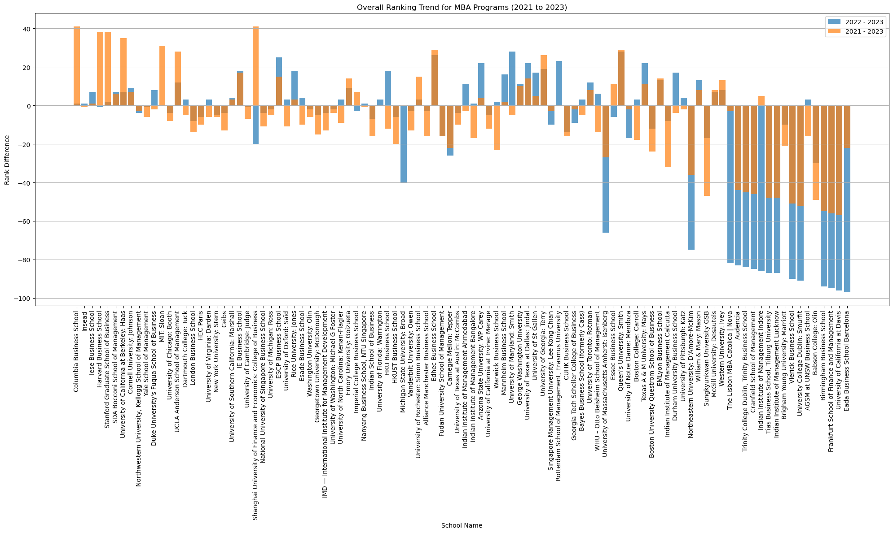

* Now let’s look at, patterns in the rankings of MBA programs

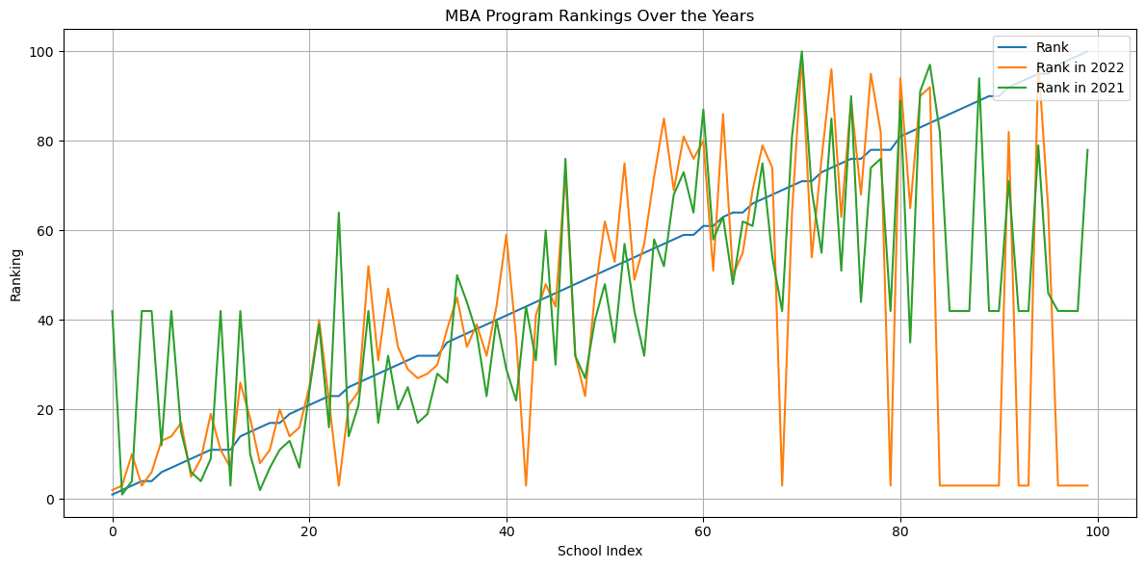

* Now let’s look at, the insights can be gained from comparing the rankings in 2021, 2022, and 2023

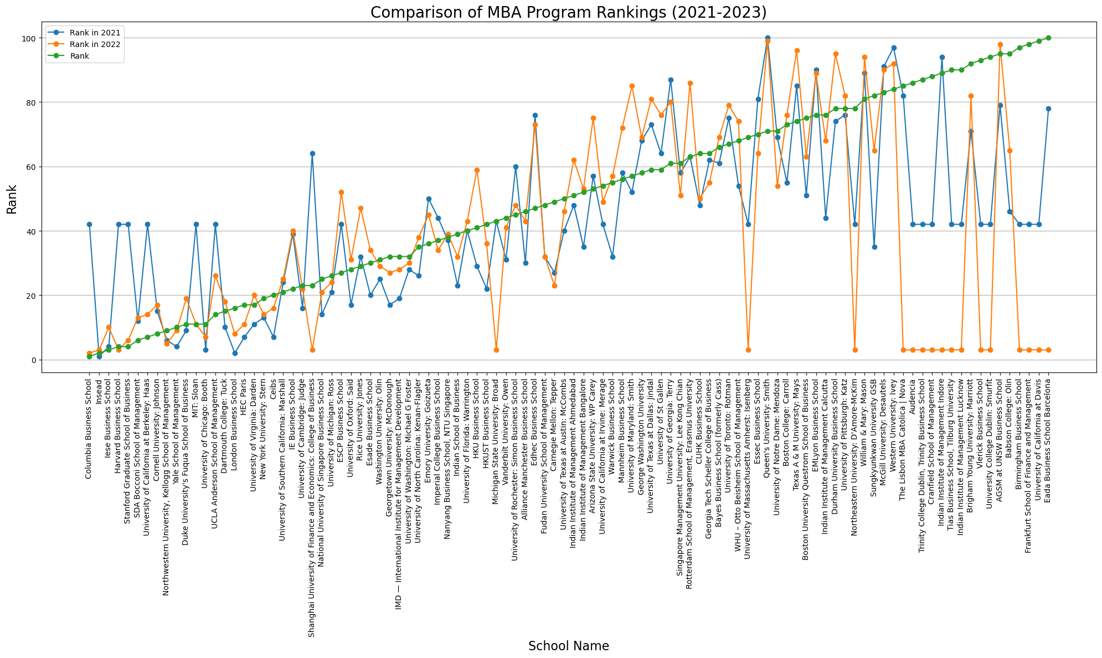

Distributions:

Let’s look at, probability density function (PDF) of Female Faculty (%):

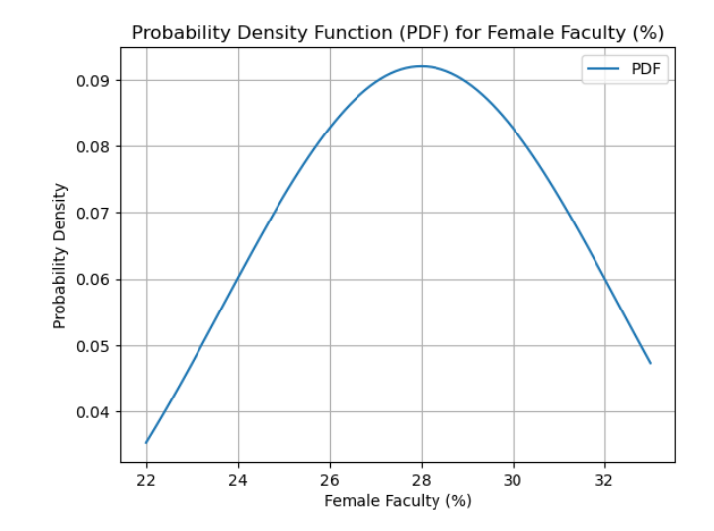

Hypothesis Testing:

T-Test: The t-test is used to compare the mean. In this we perform T-test on “Salary today” section. And the results of the test are as follows:-

Mean salary: 220376.6

t-statistic: 1.6248497153861678

p-value: 0.1795194563593551

Fail to reject null hypothesis

Insights and Findings:

Analyzing the data provided across various dimensions, including MBA program rankings, alumni networks, diversity, and environmental and social governance (ESG) initiatives, and much more we can draw several overarching insights and conclusions:

1. Diversity and Inclusivity:

There is a growing emphasis on diversity and inclusivity in MBA programs, as seen in the representation of female faculty and international board members. Some schools, such as IE Business School, stand out for having a high percentage of international board members, reflecting their global approach.

2. Rankings and Performance:

MBA program rankings can vary significantly from year to year, with some schools consistently performing well, while others experience fluctuations. Top schools like Columbia Business School and Insead consistently maintain their positions, while others may see shifts in rankings due to various factors.

3. ESG and Sustainability:

ESG and net-zero teaching are emerging as important criteria in evaluating MBA programs. Schools like Insead and IE Business School are recognized for their efforts in this area. This reflects a growing awareness of the importance of sustainability and social responsibility in business education.

4. Alumni Networks:

Alumni networks are an integral part of MBA programs, and they can influence a school's reputation and career opportunities for graduates. Schools like Columbia Business School and Harvard Business School have strong alumni networks.

5. Data Quality and Participation:

It's important to note that not all schools consistently provide data for all dimensions, leading to gaps in the analysis. Some schools may choose not to participate in certain rankings or surveys.

6. Future Trends:

The data suggests that MBA programs are evolving to meet changing demands and priorities, such as sustainability, diversity, and global perspectives. As the business landscape continues to evolve, MBA programs are likely to adapt accordingly.

7. School-Specific Insights:

Each school has its unique strengths and areas of improvement. Prospective MBA students should consider these factors in alignment with their career goals and values.

8. Continuous Monitoring:

MBA program rankings and performance should be monitored over time to assess

trends and identify changes in the competitive landscape.

Limitations:

Here are some of the limitations I faced during performing EDA:

Limited or missing data: The dataset might have missing or incomplete information for some schools, which can limit the scope of my analysis.

Data quality issues: Inaccuracies, inconsistencies, or errors in the dataset can affect the reliability of my analysis.

Data bias: The dataset might be biased toward specific regions, types of business schools, or criteria used for ranking, which could skew my analysis.

Privacy concerns: The dataset may contain sensitive or private information about individuals associated with the business schools. Ensuring compliance with data privacy regulations is essential.

Ethical considerations: Be mindful of potential ethical issues when working with data, especially if the dataset contains information that could harm the reputation of schools or individuals.

Rankings can be subjective: Rankings of business schools are often based on criteria that are subjective or proprietary. Understanding the ranking methodology and its limitations is crucial for a meaningful analysis.

Limited Variables:

The dataset may not include all the variables of interest. For a comprehensive analysis, need to supplement it with external data sources.

Time Sensitivity:

The dataset may not be up-to-date, and rankings can change over time. It's essential to consider the relevance of the data to the present day.

Recommendations:

here are some general recommendations that I might consider:

In-Depth Analysis of High-Impact Factors: Identify the factors that strongly correlate with the ranking or performance of business schools. Explore these factors in more detail to understand their impact. This may involve conducting regression analyses, hypothesis testing, or using machine learning models to predict rankings.

Benchmarking and Peer Comparisons: While comparing the top 100 business schools with their peers or with schools that are close to the ranking threshold. This can help identify areas where schools can improve and potentially move up in the rankings.

Identify Outliers: While examining schools that deviate significantly from the expected patterns. These outliers may provide insights into what distinguishes high-performing schools or schools that have room for improvement.

Qualitative Research: Supplement quantitative analysis with qualitative research, such as interviews or surveys with school administrators, students, or employers who hire graduates from these schools. This can provide insights into the qualitative aspects that contribute to a school's reputation and ranking.

Conclusion:

In conclusion, choosing the right MBA program is a critical decision influenced by various factors, including rankings, diversity, alumni networks, and sustainability efforts. Prospective students should conduct thorough research, consider their individual goals and values, and recognize that rankings alone may not capture the full picture of what each program has to offer. The business education landscape is evolving, with an increasing emphasis on responsible and inclusive leadership, making it an exciting and dynamic field for future business leaders.

Reference:

* Kaggle
* Python Libraries: Common libraries for data analysis in Python include Pandas, NumPy, Matplotlib, Seaborn, and Scikit-Learn.
* Jupyter Notebooks: Jupyter notebooks are widely used for interactive data analysis and reporting.

Acknowledgement:

I want to extend my appreciation to Shivangini Gupta ma’am, who provided invaluable guidance and expertise throughout the project. Their mentorship was instrumental in shaping the direction of the analysis. I am indebted to the developers of data analysis libraries for creating powerful software that facilitated data cleaning, visualization, and statistical analysis. Lastly, I would like to acknowledge the feedback and insights received from my friends. Their constructive feedback significantly improved the quality of this project.

Project Code:

Dataset link:

<https://www.kaggle.com/code/khushipitroda/ft-global-business-school-top-100-mba-ranking-2023>

Presentation link:

<https://drive.google.com/drive/folders/14m6YwtunbX3vvrn7Rijom3Ey20UE09Wu?usp=drive_link>

Project link:

<https://drive.google.com/drive/folders/1Sb6O7n9_In1cz7tq3eUYEcoZE0s6GhhZ?usp=drive_link>